SPACE ART TRACK SCREENING

Space Art Screenings – Room H and Room 201, Salon F2

May 4, 2006, 10:00 AM – 12:00 Noon - Room H
May 5, 2006, 9:00 AM – 12:00 Noon – Room H
May 4 – 7, 2006, Daily from 9:00 AM – 6:00 PM – Room 201

Feature fascinating art and space science collaborations created by various space artists, new works in film and special documentaries presented in collaboration with The Hubble European Space Agency Information Center, Maison d’Ailleurs, the STUDIO for Creative Inquiry at Carnegie Mellon University, Space Art One and the Zero Gravity Arts Consortium.

SPACE ART TRACK SCREENINGS SCHEDULE

THURSDAY, MAY 4, 2006

10:00 – 10:15 Science Fiction Technology Fact

Selected works from a European Space Agency’s exhibition based on a study that was carried out by Maison d’Ailleurs in Yverdon-les-Bains, Switzerland, which houses one of the world’s largest collections of science fiction literature in the world. “Artwork has played an influential and central role in science fiction literature. It has partly defined the scope of the genre and has brought the startling and imaginative visions of outer space, exploration of other worlds, interplanetary spaceflight and extraterrestrial beings into the minds and consciousness of the general public. In magazines and books, film and television, advertising and video, the artist’s vision has transformed words into dazzling and compelling images that still life the spirits and brighten the soul.” The presentation of stills from the collection juxtaposes images of what say the space station actually looks like today compared with how artists many years ago imagined they might appear, long before they were on the drawing boards and even before the first satellite had been launched. Exhibition component facilitated by David Raitt, Senior Technology Officer, European Space Agency and Patrick Gyger of the Maison d’Ailleurs in Yverdon-les-Bains, Switzerland

10:15 – 11:00 Microgravity

A film by David Ethan Sanders, written by Seth Talley, starring Tarika Brandt and Peter Marks, production design by Mamiko Otsubo (www.microgravityfilm.com)

Microgravity tells the story of Eniko, a young Russian Cosmonaut in orbit around the moon. Eniko must fight for her survival against cabin fever, technical difficulties and self-doubt when her return to Earth is repeatedly postponed.

A presentation by Seth Talley and David Ethan Sanders will follow the screening.

11:00 – 12:00 SPACE ART: Exploring New Territories!
(This program will repeat throughout the conference in Room 201)

In 2003, the International @rt Outsiders Festival, presented an historical event based on the "Space Art" theme, which was held at the Maison Européenne de la Photographie. This was the very first time a festival, exclusively dedicated to space art, have been organized in France. What needs to be done is to define "Space Art" in general terms, without going into a long drawn-out listing of all the disciplines that it covers, which in fact encompass almost all fields of contemporary creation.

"Space Art" is all those contemporary artistic practices that are inspired by space research or space activity. It is, therefore, not an aesthetic current that imposes shared formal rules of presentation or representation, but rather an artistic current defined by a subject: space, drawing on a community of passionate, lively interests by an infinite scope of investigation that is as yet little explored.

The panorama of the works which are shown here enables us to forcefully demonstrate the extraordinary vitality of contemporary creation via the novelty and diversity of the fields of experimentation that it covers: artistic experiments in weightlessness, collective and participatory works intended for space voyages, sub-orbital and environmental projects, multimedia installations based on radio-astronomy and radio-telescopy, cosmic representations, weightless sculpture and architecture, digital creations concerning fantasy, esthetics or the history of the conquest of space.

These unique artists, painters, plastic artists, architects, sculptors, film makers, musicians and poets appropriate each in their own way the collective imagination linked to the exploration of space, providing us with fascinating works, that reveal a particular awareness of the incomparable social-cultural changes that are associated with technological progress.

This video program tries to illustrate to the prodigious force of evocation that this Terra Incognita has always held for the human community.

Jean-Luc Soret, Curator
Festival @rt Outsiders / Maison Européenne de la Photographie / Paris / France
Web : www.art-outsiders.com - E-Mail : soret@art-outsiders.com

12:00 – 12:30 Frank Pietronigro ‘Drift Painting’ in a Microgravity Environment

Video documentation of Research Project Number 33: Investigating the Creative Process in a Microgravity Environment featuring Frank Pietronigro engaged in the process of creating “Drifting Painting’ aboard NASA’S KC135 turbojet as a part of the NASA Reduced Gravity Student Flight Program, a program of the Texas Space Grant Consortium produced in collaboration with the California Space Grant Program and the San Francisco Art Institute.
(www.pietronigro.com)

FRIDAY, MAY 5, 2006

9:00 – 10:30 HUBBLE: 15 Years of Discovery

Presented in collaboration with The Hubble European Space Agency Information Center (www.spacetelescope.org). The Hubble Space Telescope is a project of international cooperation between European Space Agency & NASA.

The NASA/ESA Hubble Space Telescope is one of the most successful scientific projects of all times. It is based on a collaboration between the American space agency NASA (85%) and the European Space Agency ESA (15%); a collaboration that extends across national boundaries and between different scientific and engineering communities. Hubble is a space-based telescope orbiting almost 570 km above our atmosphere.

By presenting this film in the context of the Space Art Track the Co-Chairs wish to honor HUBBLE and the collaborating team as creators of some of the most sublime images and contemporary space art created during our age.

10:30 – 10:45 Student Works: Space Art Studio Seminar, College of Fine Arts, Carnegie Mellon University

This video presentation will highlight new concepts for space art projects conceived and devleoped by fine art students participating in Lowry Burgess's Space Art Studio Seminar at the College of Fine Arts, Carnegie Mellon Universtiy, Spring Semester, 2006.

10:45 – 11:00 Kitsou Dubois: Experimental Movement in Altered Gravity Conditions

This video screening will feature highlights of work created by Kitsou Dubois. Kitsou DUBOIS, dancer, choreographer and artistic director of Ki Productions
The following information is provided by the SPACEARTS.INFO database (http://www.spacearts.info):

For several years now, Kitsou Dubois has been developing a process of experimental movement performed in an environment of altered gravity conditions.

She intervenes in the domain of art and science, creating an insight into the rapport between humans and their environment. By appropriating the new spaces created by space travel, she has contributed to the emergence of a new artistic space. From this new relationship with movement she brings out references, such as, the establishment of a subjective verticality, continuous flow motion, the actual existence of an "in-between" space… and this in water, on a trampoline and in a state of weightlessness aboard a parabolic flight.

These experiments have engendered a poetic domain where the video image is always present as a trace for memory. That ingrained fear of falling is overcome by the freedom apparent in the floating movement and by the release of a body no longer weighed down. Here, one can experience empty space where survival does not depend on keeping one’s balance; where one can establish an identity with no other reference but the unknown in all its instability.

FRIDAY, MAY 5, 2006 (CONT’D)

In Kitsou Dubois’ choreographic and visual process, the weightless body seems like the symbolic scene for the discovery of new spaces , enabling a rediscovery of the self, giving another meaning to weight and gesture.

Through dancing and working at constantly re-appropriating the body, Kitsou Dubois raises the issue of its place in our communication systems: is it a spirit, an imagination no longer confined by corporeal boundaries, or is it a physical entity which can redefine itself through the exploration of infinite time and space?

11:00 – 12:00 SKY STUDIO: ZGAC Parabolic Research Flight for Artists – Video Documentation and discussion with the Flight Team Artists with Frank Pietronigro and other members of the flight team.

HUBBLE: 15 Years of Discovery

Presented in collaboration with The Hubble European Space Agency Information Center (www.spacetelescope.org). The Hubble Space Telescope is a project of international cooperation between European Space Agency & NASA.

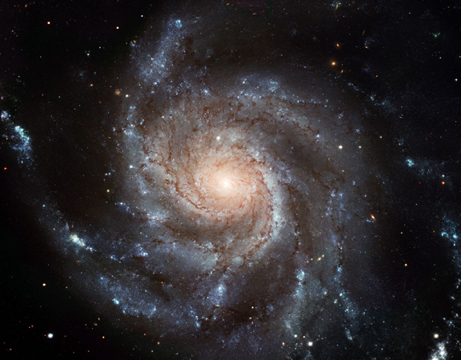
Messier 101 (the Pinwheel Galaxy)
Image Courtesy of the European Space Agency & NASA

Kitsou Dubois: Experimental Movement in Altered Gravity Conditions

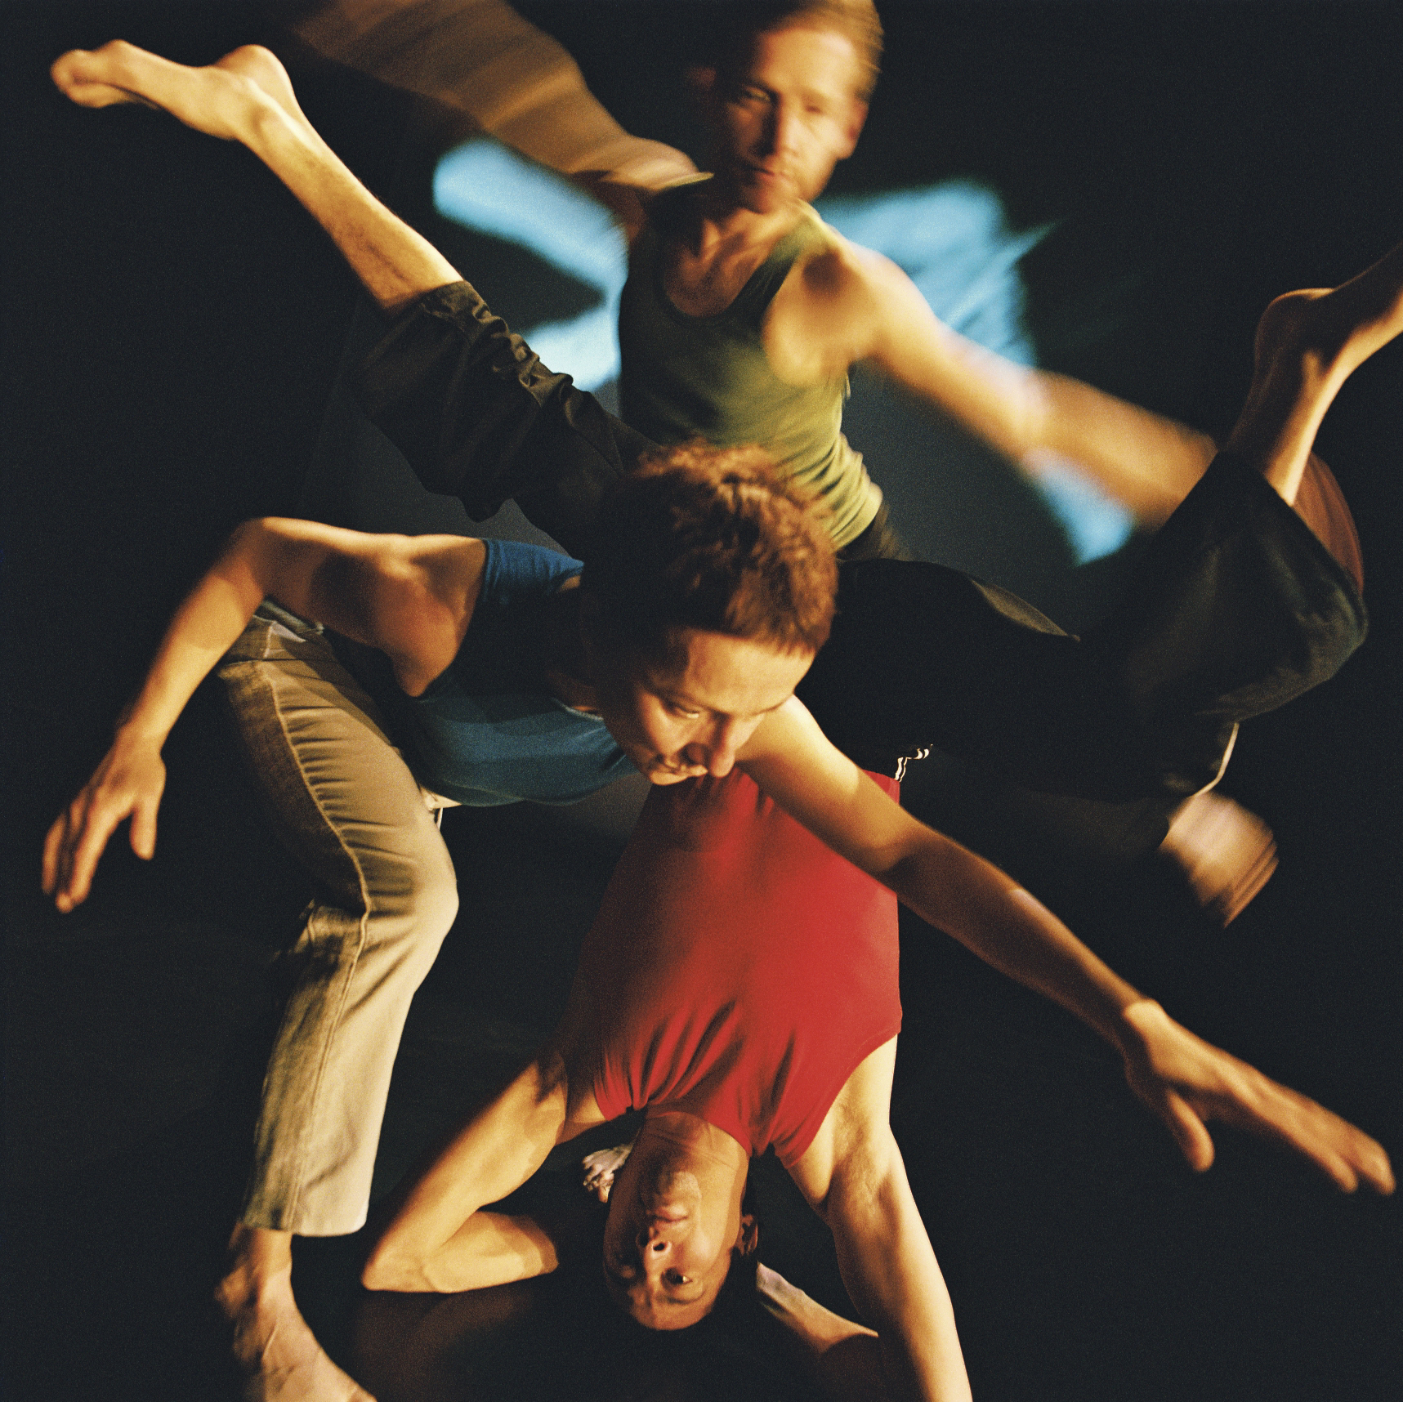 (Copyright : Quentin Berthoux – Analogie)

In 1990, the French choreographer Kitsou Dubois did on her first parabolic flight organised by the CNES.(French space agency). She has developed an aesthetic approach and knowledge about the body gravity. So far, she has taken part in 18 parabolic flights.

As part of her partnerships with scientists and researchers, Kitsou Dubois has developed projects based on the body faced with states of altered gravity : she worked with performers (dancers and acrobats) under water, with circus apparatus (trampoline, trapeze, etc…), and in micro-gravity during parabolic flights. In her creations, she now focuses on the emergence/apparition (“birth”) of the movement and the ambiguity of the limits of the body.

Kitsou Dubois creates dreamlike choreographies, which distort the audience’s perception. Movements alternate between disorientation and anchorage. The bodies of the performers and the bodies of the spectators are linked in a common disorientation.

Her aim is to rediscover the fundamental movements of dance through experimenting another dimension of space and time: microgravity.

Gravity is such a powerful force it masks all other underlying forces that are also present on Earth. However, these other forces also participate to the flow of movement within the body, and help to create a “dilated” body through which the performer expresses him/herself.

Artistic director: Kitsou Dubois
Video Directed by Guillaume Allaire
Contact : Ki Productions – Albane Ahrens – albaneetbientot@yahoo.fr

Artistic team : Chloé Moglia, Laura de Nercy, Manu Debuck, Xavier Kim, Bertrand Lombard, Chloé Ban, Jorg Müller

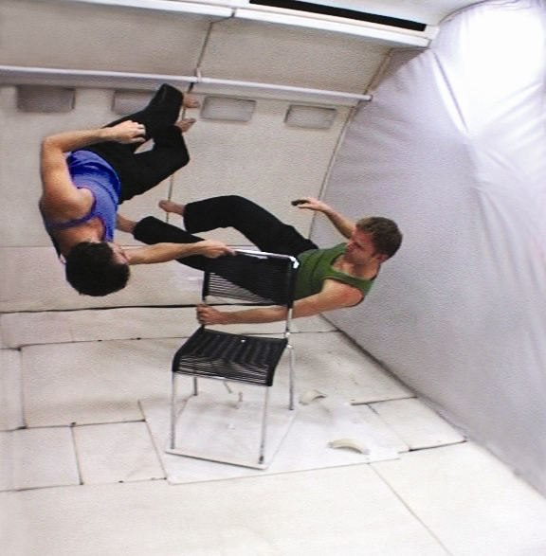

(Copyright : Ki Productions)

‘Drift Painting in a Microgravity Environment’

Video documentation of Research Project Number 33: Investigating the Creative Process in a Microgravity Environment featuring Frank Pietronigro engaged in the process of creating “Drifting Painting’ aboard NASA’S KC135 turbojet as a part of the NASA Reduced Gravity Student Flight Program, a program of the Texas Space Grant Consortium produced in collaboration with the California Space Grant Program and the San Francisco Art Institute.
(www.pietronigro.com)

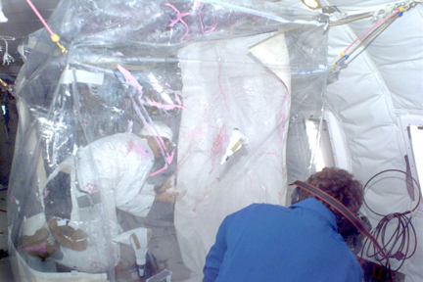

‘Drift Painting’ in a Microgravity Environment, Frank Pietronigro, Artist, 1998
(Original Video Footage: Courtesy of NASA)

Microgravity

– a film by David Ethan Sanders, written by Seth Talley, starring Tarika Brandt and Peter Marks, production design by Mamiko Otsubo (www.microgravityfilm.com)

Microgravity tells the story of Eniko, a young Russian Cosmonaut in orbit around the moon. Eniko must fight for her survival against cabin fever, technical difficulties and self-doubt when her return to Earth is repeatedly postponed.

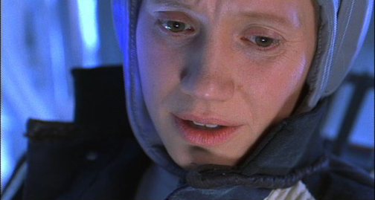
Tarika Brandt in Microgravity

Special Presentations
Including films, plans and projects created by students participating in the Space Art Studio Seminar held at the College of Fine Arts, Carnegie Mellon University during the Spring 2006 semester working under the guidance of Professor Lowry Burgess.

SPACE ART: Exploring New Territories!

In 2003, the International @rt Outsiders Festival, presented an historical event based on the "Space Art" theme, which was held at the Maison Européenne de la Photographie. This was the very first time a festival, exclusively dedicated to space art, have been organized in France. What needs to be done is to define "Space Art" in general terms, without going into a long drawn-out listing of all the disciplines that it covers, which in fact encompass almost all fields of contemporary creation.

SPACE ART: Exploring New Territories! (CONT’D)

"Space Art" is all those contemporary artistic practices that are inspired by space research or space activity. It is, therefore, not an aesthetic current that imposes shared formal rules of presentation or representation, but rather an artistic current defined by a subject: space, drawing on a community of passionate, lively interests by an infinite scope of investigation that is as yet little explored.

The panorama of the works which are shown here enables us to forcefully demonstrate the extraordinary vitality of contemporary creation via the novelty and diversity of the fields of experimentation that it covers: artistic experiments in weightlessness, collective and participatory works intended for space voyages, sub-orbital and environmental projects, multimedia installations based on radio-astronomy and radio-telescopy, cosmic representations, weightless sculpture and architecture, digital creations concerning fantasy, esthetics or the history of the conquest of space.

These unique artists, painters, plastic artists, architects, sculptors, film makers, musicians and poets appropriate each in their own way the collective imagination linked to the exploration of space, providing us with fascinating works, that reveal a particular awareness of the incomparable social-cultural changes that are associated with technological progress.

This video program tries to illustrate to the prodigious force of evocation that this Terra Incognita has always held for the human community.

Jean-Luc Soret, Curator
Festival @rt Outsiders / Maison Européenne de la Photographie / Paris / France
Web : www.art-outsiders.com - E-Mail : soret@art-outsiders.com

1) “COLLISION II”, Richard Clar, (2003)
Music: Marc Battier
Durée: 4:00 mn

http://www.arttechnologies.com

COLLISION II, an orbital debris constellation sculpture in low-Earth orbit, is represented in a multimedia video installation featuring music by the French composer, Marc Battier. Attention is focused on the serious problem of orbital debris, particularly in low-Earth orbit.

Selected for COLLISION II, 192 orbital debris objects (color-coded by country of origin) are shown in the installation video along with the remainder of the 10,000 objects (small white dots) currently in the U.S. Space Command's catalog of tracked orbital debris objects. Surrounding our planet Earth, the trajectories of all of these debris, which at first might appear to be chaotic, are in fact known and listed in the U.S. Space Command's catalog of orbital debris objects in space. Using data from this catalog, and a super-computer, the Naval Research Laboratory in Washington, D.C., created the simulations seen in the COLLISION II presentation.

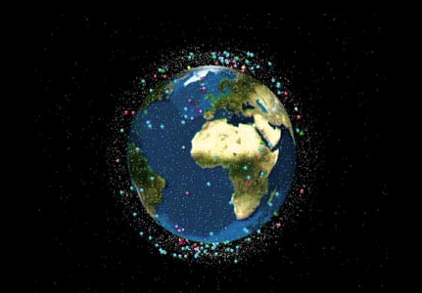

2) “KEO”, Jean-Marc Philippe, (2001)
Durée: 5:15 mn

Selected as the " Project for the 21st century" by Unesco, Keo is a satellite prepared for launching by 2007 for a long journey around the planet Earth in order to land in about 50 000 years later and deliver to our remote descendants any message given nowadays by each of us.
Once Keo on orbit, all our messages - which will remain strictly anonymous within the archives kept on Earth - are going to be analyzed by linguists and sociologists. The content will be summarized by cartographers in order to set up a public debate, a scientific device which will enable us to answer a couple of main questions such as "who are we?" and what kind of world and society could we build starting today in terms of human betterment?

www.keo.org

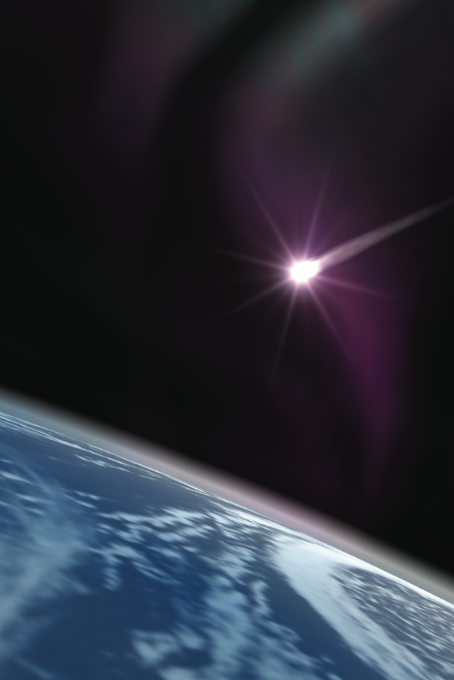

3) “OPEN SKY”, Ewen Chardronnet and "RT32", Rasa Smite, Martins Ratkins, Raitis Smits, (2003)
Durée: 24:20 mn

"Open Sky" looks how artists explore conversions from military to civilian in space and sky arts. It presents a film that shows how to open the sky to stimulate possible conversions and investigate orbital information systems in the context of post-Apollo to post-Cold War/DesertStorm esthetics and politics. “Open sky” shows also the background of the conversion for civil use of the "RT 32" telescope of Irbene in Latvia.

http://acoustic.space.re-lab.net
http://www.rixc.lv
http://www.radioqualia.net

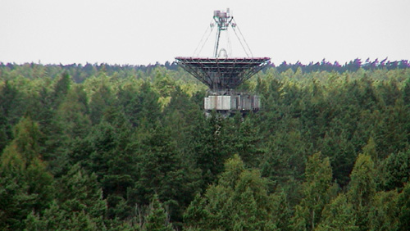

4) “SIGNATURE TERRE” + “PROGRAMME BIOSPACE” + “ZERO G. ART”, Pierre Comte, (2003)
Durée: 7:00 mn

Visible from space, "Signature Terre" is a gigantic ground installation that reaches its full significance with the satellite views presented.

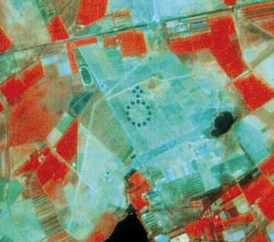

"Biospace Program" a project that endeavors to prove that the ideal architecture for weightlessness is a sphere. An original work that gives us a glimpse of tomorrow's space shuttle cockpit.

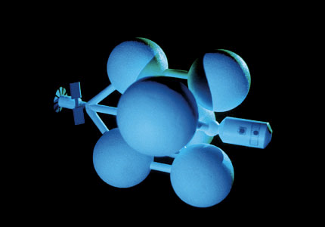

"Zero G. Art" thanks to backing by the CNES, ESA and NASA, Pierre Comte has created very particular plastic works, in which the interest lies ó amongst other things ó in the way in which they move about in space.

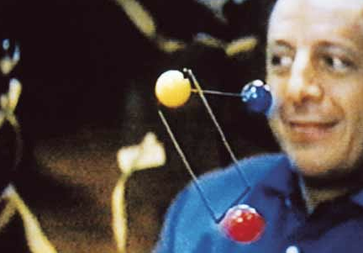

5) GRAVITATION OFF! Arts Catalyst, (2003)
Durée: 11:45 mn

The Arts Catalyst founded in 1993 by Nicola Triscott, is a European agency based in London that specializes in the relationship between art and science whose goal is to encourage dialog, exchange and collaboration between artists and scientists. This organization whose curator is Rob La Frenais thus opens up new territories and spaces for creation with the setting up of multidisciplinary research laboratories including activities such as zero gravity flights.
"Gravitation off!" leads us to discover the extraordinary video documents of these artistic experiments performed in weightlessness.

www.artscatalyst.org

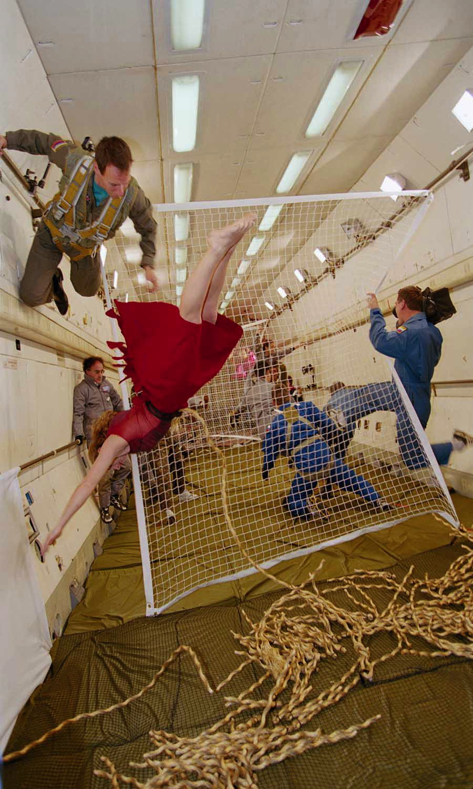

6) “COSMIC DANCER”, Arthur Woods, (1993)
Durée: 6:20 mn

On Friday, March 23, 2001: the MIR space station plunged into the south Pacific in flames. Along with the station, the "Cosmic Dancer," the first sculpture on board the MIR since 1993, that was specifically created for the station and for weightlessness, disappeared into the ocean. With no attachment points, this sculpture offers viewers a multitude of perceptual points or rather position points, creating a three dimensional kinetic relationship with the cosmonauts.
A captivating video documentary that enables the public to observe the birth and realization of this historical, yet ephemeral work.

www.cosmicdancer.com



